### AGGREGATE FUNCTIONs AND JOINs

## MIN and MAX

### MIN Function

MIN function returns the minimum value in the selected column.

The syntax of the MIN function:

SELECT MIN(column_name)

FROM table_name;

The MIN function ignores the NULL values. Thus, it retrieves the non-NULL minimum value in the selected column.

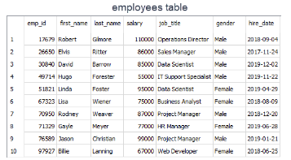

Alright, let's see it in an example. Who gets paid the lowest wage in the company?  
  
query :

SELECT MIN(salary) AS lowest_salary

FROM employees;

output :

lowest_salary

-------------

55000

We can also combine MIN function with WHERE clause. Let's move the query above to the next level. Display the female employee who gets paid the lowest.   
  
query :

SELECT MIN(salary) AS lowest_salary

FROM employees

WHERE gender = 'Female';

output :

lowest_salary

-------------

67000

The lowest salary is $67,000 among female employees.

**✍ Exercise:** Try to write the query above without using MIN function.

Click for the solution  
  
You can use ORDER BY and LIMIT keywords to get the minimum value in a selected column. This will yield the same result as in the MIN function.  
  
The MIN function can also be used with dates. For instance, display the earliest hired employee's date.  
  
query :

SELECT MIN(hire_date) AS earliest_date

FROM employees;

output :

earliest_date

-------------

2017-11-24

### MAX Function

MAX function returns the maximum value in the selected column. With the MAX function, you can find the highest salary among the employees, the most expensive products, the longest track, etc.

The syntax of the MAX function:

SELECT MAX(column_name)

FROM table_name;

The MAX function ignores the NULL values. 

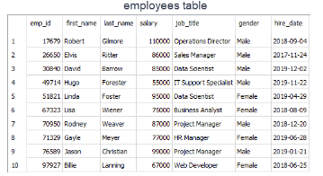

Alright, let's take the same example in the previous part. But, this time find the highest wage in the company.  
  
query :

SELECT MAX(salary) AS highest_salary

FROM employees;

output :

highest_salary

-------------

110000

We can also combine MAX function with WHERE clause as we did in the MIN function. Display the male employee who gets paid the highest.   
  
query :

SELECT MAX(salary) AS highest_salary

FROM employees

WHERE gender = 'Male';

output :

highest_salary

-------------

110000

The highest salary is $110,000 among male employees. This amount is also the highest one among all employees.

**✍ Exercise:** Try to write the query above without using MAX function.

Click for the solution  
  
You can use ORDER BY and LIMIT keywords to get the maximum value in a selected column. This will yield the same result as in the MAX function.  
  
The MAX function can be used with dates. For instance, we can display the newest hired employee's date as below:  
  
 query :

SELECT MAX(hire_date) AS newest_date

FROM employees;

output:

newest_date

-----------

2019-12-02